**Phase 6: User Interface Development (UI) – Tutor Match**

In this phase, we built a clean and intuitive interface for counselors in the **Tutor Match Console App** using Salesforce Lightning tools. The focus was on giving counselors a **360° view of students**, quick access to tutors, sessions, and courses, and streamlined navigation for follow-ups and enrollments.  
  
**1) Lightning App Builder**  
Created a custom Lightning App: **Tutor Match Console**

Navigation Items added:

* Leads (prospective students)
* Students (Contacts)
* Tutors (custom tab)
* Courses (custom tab)
* Sessions (custom tab)
* Reports  
  
  
**2) Record Pages**  
Created a custom Record Page for **Student (Contact) → Student 360**.

Added components:

* **Highlights Panel** → Shows key student details (Name, Email, Phone, Status).
* **Student360 LWC** → Custom component to display student snapshot.
* **Related Lists** → Sessions, Courses Enrolled, Assigned Tutor.

**3) Tabs**  
Created custom object tabs for:

* **Job_Post__c** (tutoring opportunities created by parents/students)
* **Session__c** (scheduled tutoring sessions)
* **Application__c** (applications submitted by tutors/students)
* **Parent__c** (parent details linked to students)

Added them to the **Tutor Match Console** app navigation.

**4) Home Page Layouts**  
Customized Home Page for counselors in the **Tutor Match Console** app:

* **Added Reports Dashboard** → shows **Job Posts by Status**, **Applications Summary**, **Upcoming Sessions**.
* **Added Recent Records component** → quick access to **Students, Tutors, Parents, and Sessions**.

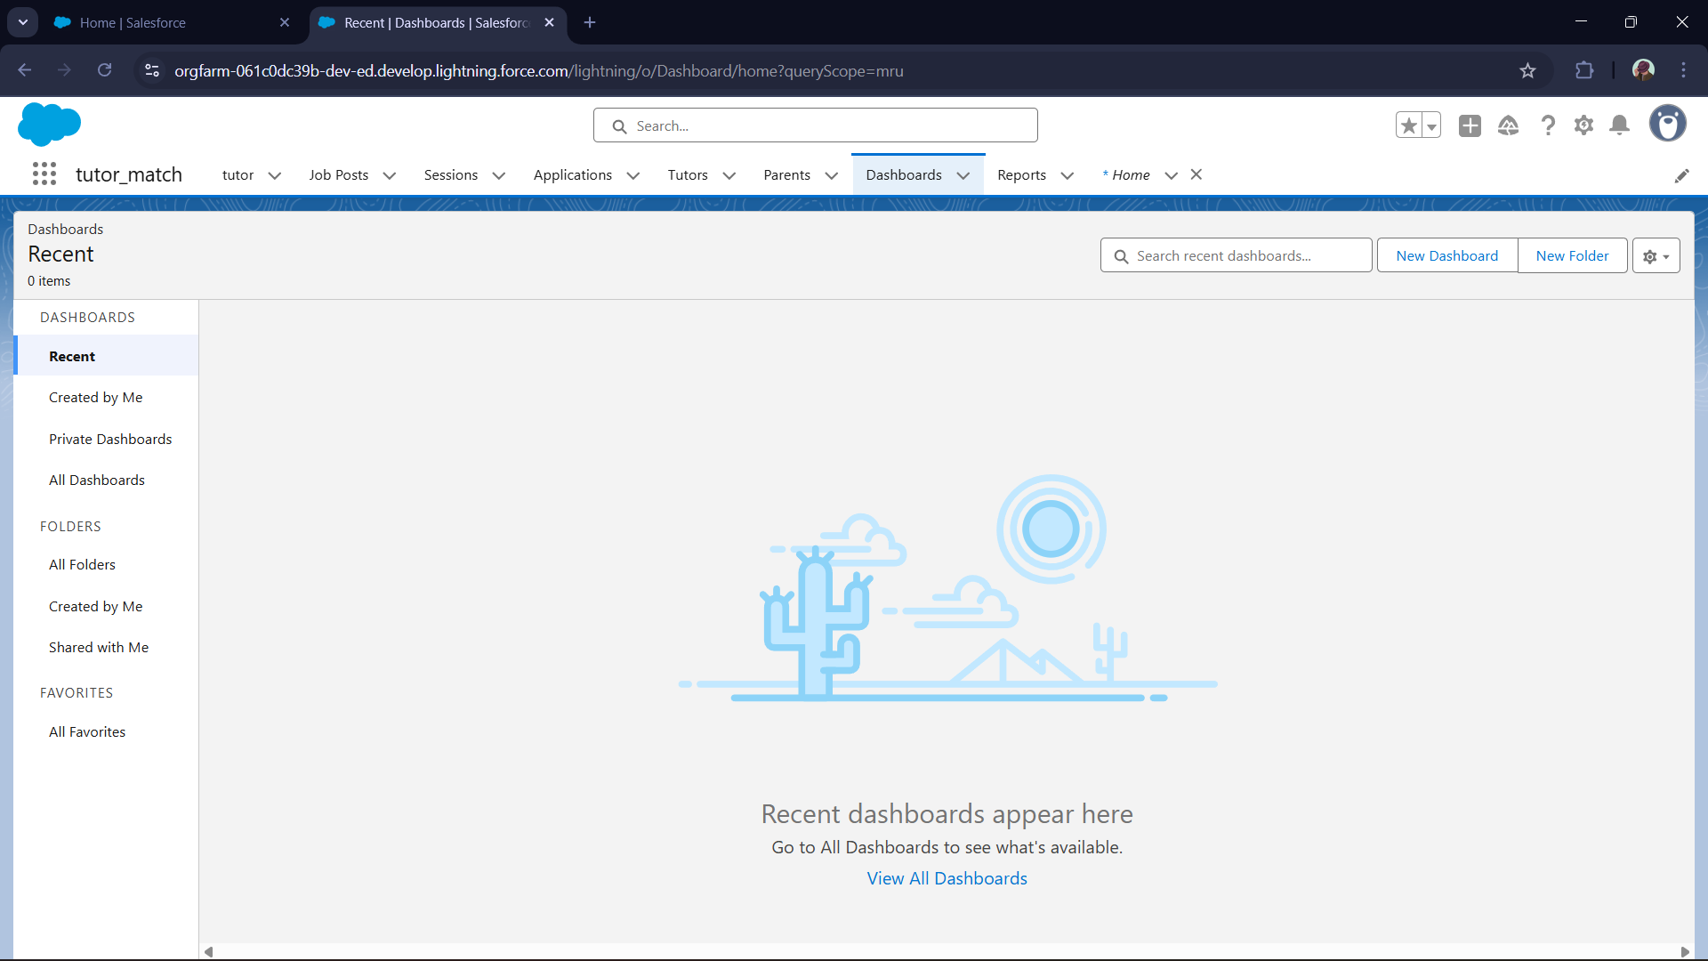  
  
**5) Utility Bar**

Configured Utility Bar in the app (desktop only):  
  
• Notes → quick note-taking during counseling calls.  
• History → navigate back to recently opened records.

For your **Tutor Match project**, the **Utility Bar** is a compact workspace at the bottom of the **Tutor Match Console** app that lets counselors quickly access important tools while working on students, tutors, sessions, and applications

**6) LWC (Lightning Web Component)**

Built Student360 LWC in VS Code and deployed to Salesforce.  
  
Files created:  
  
• student360.html  
• student360.js  
• student360.js-meta.xml  
  
☞Shows student’s Name, Email, Phone on Contact Record Page.  
  
**7) Apex with LWC**

Student360 LWC uses Lightning Data Service (getRecord), so no Apex needed.  
  
Apex service (EnrollmentService.cls) is available if needed later for enrollment actions (e.g., button to enroll student from LWC).

**8) Events in LWC**

LWC prepared to handle future button events (like “Enroll Student” or “Send SMS”).  
  
Currently displays data via reactive UI.

**9) Wire Adapters**

Used @wire(getRecord) in student360.js to fetch Contact fields (Name, Email, Phone).  
  
Data auto-refreshes when record changes.